The **Tie**, the line that connect 2 notes, means that these two notes are together

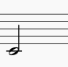 is equal to 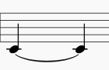 and equal to 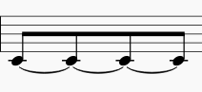

**Original + Augmented**

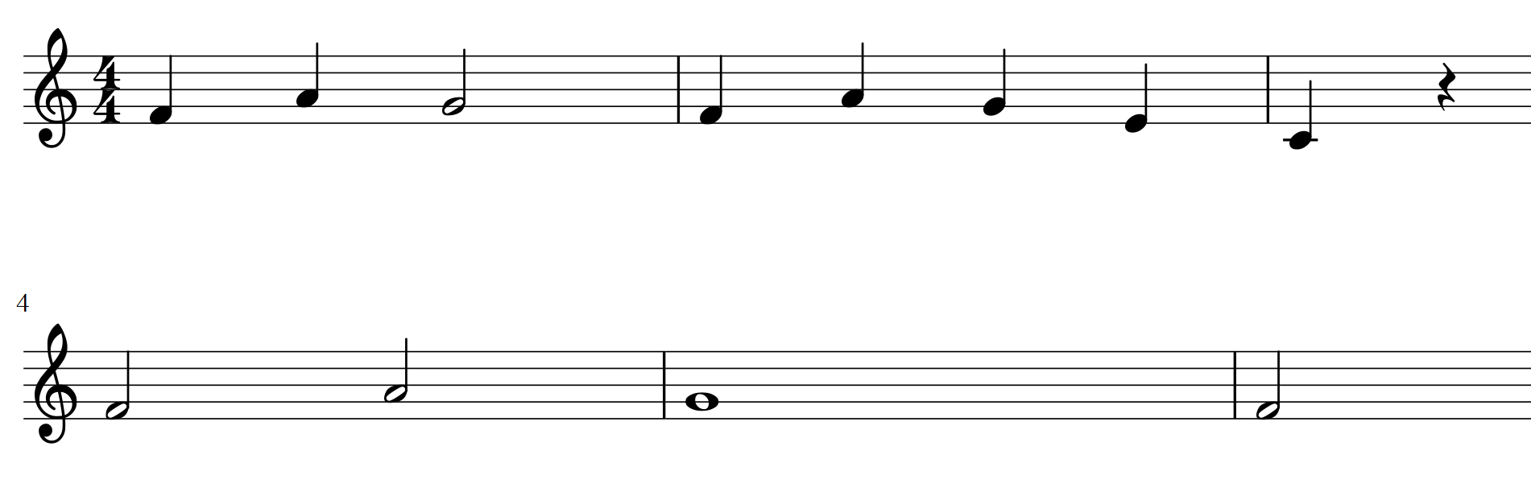

In the augmented to find the intervals you need to get the smaller rhythm figure to divide the melodies.

In this case, the smaller is a querter figure (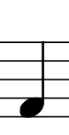 )

The result will be..

**Original + Augmented with the smaller unit**

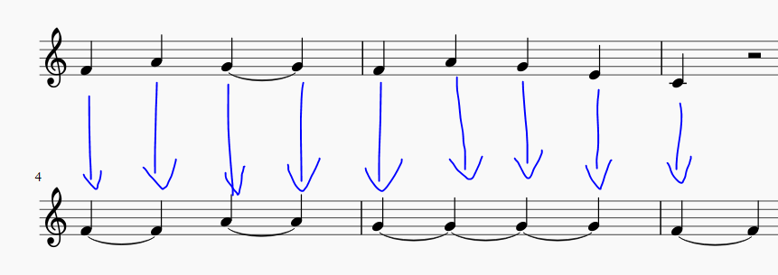

So now you can compute the intervals.

Same in the case of the diminution…

**Original + Diminution**

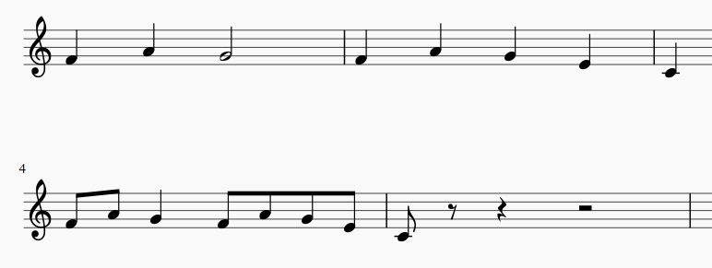

In this case the smaller unit is (1/8) 

So the result will be

**Original + Diminution with smaller unit**

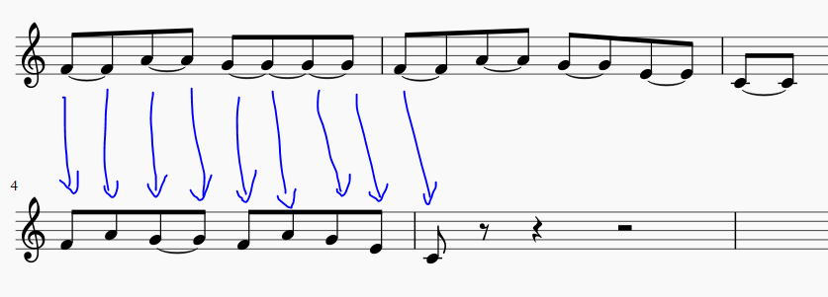

Also in the result file you will get the same amount of notes after this transformation.

The last example will be

O: F8, F8, A8, A8, G8, G8, G8, G8, F8, F8, A8, A8, G8, G8, E8, E8, C8, C8

D: F8, A8, G8, G8, F8, A8, G8, E8, C8, 00, 00, 00, 00, 00, 00, 00, 00, 00

As you see, now is more easy to calculate the results because every note in the O array is in the same index that the D array.

I propose to add another array to indicate if the note is with TIE with the next note on the transformation array

It can be a Boolean Array (T – True, F- False)

In this example will be

O: F8, F8, A8, A8, G8, G8, G8, G8, F8, F8, A8, A8, G8, G8, E8, E8, C8, C8

D: F8, A8, G8, G8, F8, A8, G8, E8, C8, 00, 00, 00, 00, 00, 00, 00, 00, 00

T: F , F , T , F , F , F , F , F , F , F , F , F , F , F , F , F , F , F